**PRESS RELEASE**

Thursday August 3rd 2023  
Contact: Kirk Elliott  
Tel: 758.518.5800  
Email: Kirk@KirkElliott.com

*NEWS*

**For Immediate Release**

**Caring Entrepreneurship: A Model For Sustainable Community-based Tourism in St. Lucia**Submitted by Kirk Elliott

A few years ago award winning [St Lucia photographer](https://StLuciaPhotoTours.com/Hello) ( <https://StLuciaPhotoTours.com/Hello> ) Kirk Elliott got invited to a rural community deep in the heart of Saint Lucia to help it develop a sense of excellence in its tourism offering after his St Lucia Photo Tour won its first TripAdvisor Certificate of Excellence.  Elliott was blown away by the tremendous potential of their tourism product.  However, he couldn’t help lamenting that residents simply didn’t see its potential and were thus content to maintain the status quo.

In grappling with the conundrum of how best to effect positive and lasting change Elliott came to the realization that rural communities are largely ill-equipped to successfully manage and operate tourism enterprises.  This led him to an idea he dubbed **“Caring Entrepreneurship”**.

**Defining Caring Entrepreneurship**

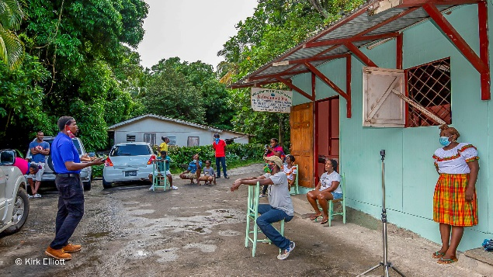In the context of tourism Elliott defines the **Caring Entrepreneur** as someone who understands how to successfully create and manage a tourism business.  The entrepreneur brings this expertise to the mutual benefit of both the community and his/her enterprise.  The caring entrepreneur nurtures and empowers the community so that it can eventually assume control of the business and grow it from strength to strength.   
  
To be successful the business arrangement must be based on mutual respect and trust.  The entrepreneur must truly care about the well-being of the community rather than exclusively about his/her bottom line.  In turn the community must recognize and appreciate the value the caring entrepreneurship brings to the table. This synergy is the foundation for an outcome in which their combined efforts yield results that far exceed the sum of the community’s and the entrepreneur’s individual efforts.

***Community President addressing rural community residents in St. Lucia***

“I will be the first to tell you that this notion of caring entrepreneurship is a counter-intuitive approach to deriving meaningful community benefits from tourism. However, from inception it was clear to me that this novel approach was an effective way of nurturing long-term success in community-based sustainable tourism development” Elliott explained when asked why would anyone make such a sacrifice to help a community when they could simply open shop and proceed to extract the maximum profit.

**Testing The Theory of Caring Entrepreneurship**

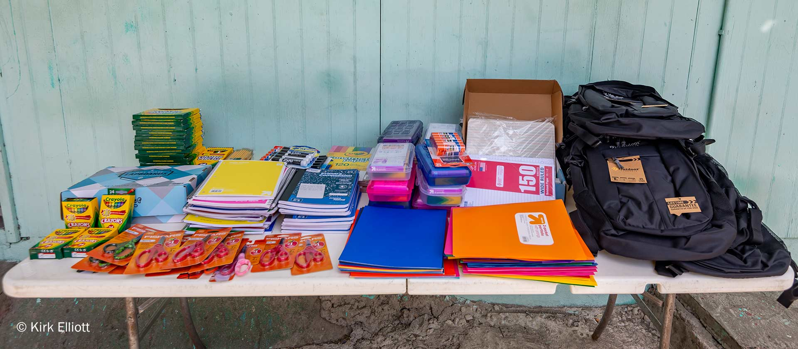After multiple false starts Elliott finally got the opportunity to test his theory in a different community after [@CoxTravelAdventures](https://www.instagram.com/coxtraveladventures/) of Danbury Connecticut, USA, outfitted an entire kindergarten class with an assortment of school supplies at the start of the 2022 school year.

**Cox Travel Adventures Donates School Supplies to a Kindergarten Class in Choiseul, Saint Lucia**

The school supplies were donated to the Dugard Combined School in Choiseul, Saint Lucia. While Dugard is a rural community deep in the heart of Saint Lucia, whatsoever the school may have missed due to its remoteness it more than made up for with heart and soul.  From the principal and teachers, to the students, to the school’s caretaker staff, they all operate like one big family and their love and caring comes shining through.

“From my initial telephone conversation with Mr. Elliott I felt like my prayers had been answered, as just the week before I had prayed that our small rural community school with limited resources would somehow gain greater visibility.  Then seemingly out of the blue there was Mr. Elliott lending a helping hand and speaking of wanting to develop a long-term relationship with our school”, stated school principal Mrs. Tessa Charles-Calderon when asked about Elliott’s support for the school.

**Connecting Young Students With Tourism**

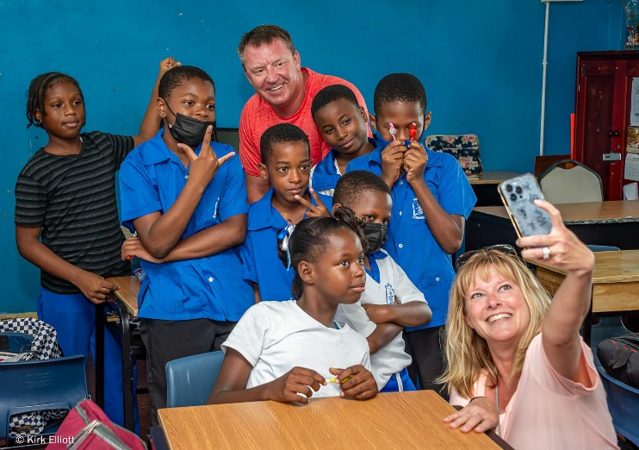Since the post pandemic return of tourism Elliott has been taking patrons of his Private St Lucia Experiences to the Dugard Combined School where they get to engage with students first hand.  Elliott invites his clients to bring over school supplies based on the needs of the school, and the general consensus of visitors is that their engagement with the students has been a highlight of their Saint Lucia vacation.

***Grade 5 Students at the Dugard Combined School in Choiseul, St Lucia, taking selfie with visiting tourists***

For the students – they have come to appreciate tourists as people just like themselves rather than as some abstract term they hear about on the radio or see on television newscasts.

**A Burning Visitor Desire For Authentic Community-based Experiences**

Today, more and more visitors are seeking authentic experiences that immerse them in the culture, history, cuisine and lived experiences of locals.  These visitors wish to know that their money is creating a positive impact in the lives of the indigenous peoples of the destinations they visit.  Towards this end such visitors are actively seeking out ways of connecting to and engaging with local communities and buying directly from them.

**What’s Next For The Dugard Combined School**

Students at the school have said they would love to have a proper playground at their school and the principal and teachers consider this an excellent idea that will teach the children about caring and sharing, among other things.

Elliott has engaged many of his professional friends to lend a helping hand to the Dugard Combined School’s Playground Project.  From an engineer who has assessed the required earth works, to an architect who has produced architectural renderings for the playground, just about everyone Elliott has reached out to has lent their support and even gone way beyond his wildest expectations.

“The overwhelming support of everyone I have reached out to has emboldened me to invite both the teachers and the students to dream big scary dreams and then together let’s go out and make those dreams come through!” Elliott passionately commented when asked his thoughts on this playground project and beyond.

During the 2022/23 school year Elliott worked with the school to complete Phase 1 of the Playground Project in the form of the painting of educational games in the schoolyard.  Not to let an opportunity go to waste, the school incorporated the games painting project into students’ School Based Assessment (SBA).  This SBA is a practical activity students must successfully complete in order to graduate and gain admission to a secondary school.  
  
From the video below of the official launch of the games it is clear that the students’ efforts were well received.

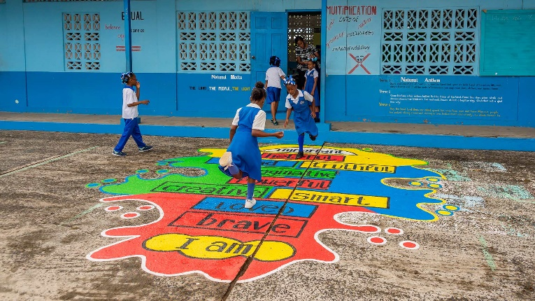

🡸 **Place Video Here**

Video Link: <https://StLuciaPhotoTours.com/DugardPlayground>

**Saint Lucia Diaspora Support**

Saint Lucians, both in the diaspora and at home who participated in Elliott’s recent [***I Am Lucian Webinar Series***](https://www.youtube.com/playlist?list=PLX9QpVzHtwSUmWDV7mD3sT6WleueF57yD) have been super supportive too.  Some have volunteered to fly down to Saint Lucia to assist with the playground construction, while others are sourcing electronic smart-boards for multiple schools on the island, and entry level STEM (Science, Technology, Engineering & Math) training for students.

*“I am delighted by the outpouring of support and excited about the possibilities that lie ahead for community youth development and empowerment. It is refreshingly heartwarming to see what is possible through the power of collective caring and sharing”* Elliott commented regarding the Saint Lucian diaspora support.

**Creating an International Benchmark of Sustainable Community-based Tourism in Small Island Developing States (SIDS)**

When Elliott embarked on this journey of seeking to empower a rural community little could he have imagined where the journey would lead.  In the process of understanding and overcoming the obstacles he encountered he has come to realize that those we consider rural poor enjoy a richness of life and living that remains largely unrecognized.However they are at risk of losing much that they hold dear due to the rapid environmental degradation of the world at large.  For this reason, empowering them through an appreciation of the benefits of sustainable community-based tourism is a powerful way of preserving much that is rapidly being eroded away.

“I am super excited about this idea of Caring Entrepreneurship and my goal is to see this community engagement starting with the Dugard Combined School project manifest into an International Benchmark of Sustainable Community-based Tourism in Small Island Developing States” said Elliott when asked what was the overall outcome he envisions.

…and at the rate at which this intervention is progressing he just might be on to something.

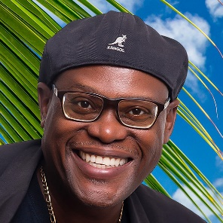**About Kirk Elliott**

Kirk Elliott is an award-winning St Lucia Photographer, Sustainable Tourism Advocate and National Geographic Certified Educator.

Kirk is the Founder of the St Lucia Photo Tour where he introduces visitors to authentic Saint Lucia culture, history and cuisine through the medium of photography… [Kirk@KirkElliott.com](mailto:Kirk@KirkElliott.com) | <https://StLuciaPhotoTours.com/Hello>  
###